Experiment worksheet

7.5 Force equals mass × acceleration

Pages 164–165 and 224

Experiment 7.5B: Accelerating masses

Aim: To determine the relationship between mass and acceleration.

Materials

• Dynamics trolley

• String

• Mass hanger and brass 50 g masses

• Several 1 kg masses

• Desk-mountable pulley wheel with clamp

• Electronic balance

• Stopwatch

• Tape measure or ticker timer

• Power supply

• Ticker tape

• Cushioning material

Method

1 Clamp the pulley wheel to the edge of the desk. Try to arrange the largest height above the floor as possible (Figure 1).

2 Attach one end of the string to the dynamics trolley and the other end to the mass hanger, carrying a total of approximately 200 g of mass (Figure 2).

3 Hang the masses over the pulley so they can pull the trolley along as they fall to the floor. Place the cushioning material under the weights to reduce impact.

4 Record the motion of the trolley as the masses fall, by using a motion sensor, timing with a stopwatch or recording the motion on ticker tape (Figure 3).

5 Successively add 1 kg masses to the trolley and repeat your measurements several times.

  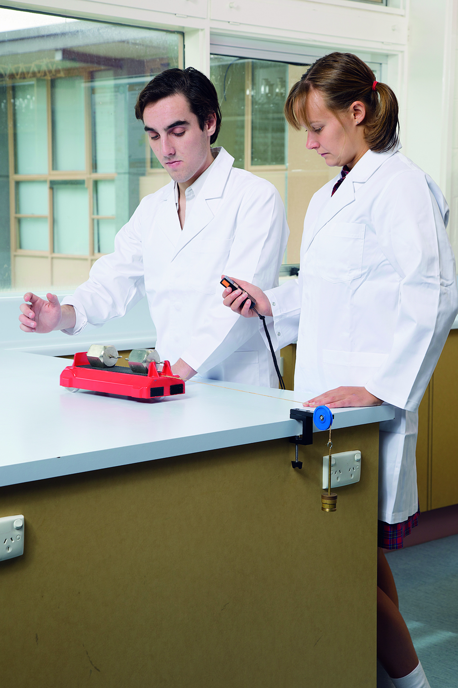

Figure 1 Figure 2 Figure 3

Results

|  |  |  |  |  |  |
| --- | --- | --- | --- | --- | --- |
| Mass Added to Trolley | Time for  Trial 1 (s) | Time for  Trial 2 (s) | Time for  Trial 3 (s) | Average  Time (s) |  |
|  |  |  |  |  |  |
|  |  |  |  |  |  |
|  |  |  |  |  |  |
|  |  |  |  |  |  |

1 Calculate the acceleration of the trolley using the formula: (2 × the distance travelled ÷ time squared).

2 Plot a graph of acceleration versus total mass. This should give an inverse graph.

Discussion

1 How did increasing the mass on the trolley affect the acceleration of the trolley?

|  |
| --- |
|  |
|  |
|  |

2 Relate your experiment to a real-life example.

|  |
| --- |
|  |
|  |
|  |
|  |

Conclusion

What is the relationship between mass and acceleration?

|  |
| --- |
|  |
|  |
|  |
|  |
|  |